**Experiment-3**

**AIM:- Working with Docker Volume**

**Steps to Complete:**

1. **View all Volume in Docker:-**

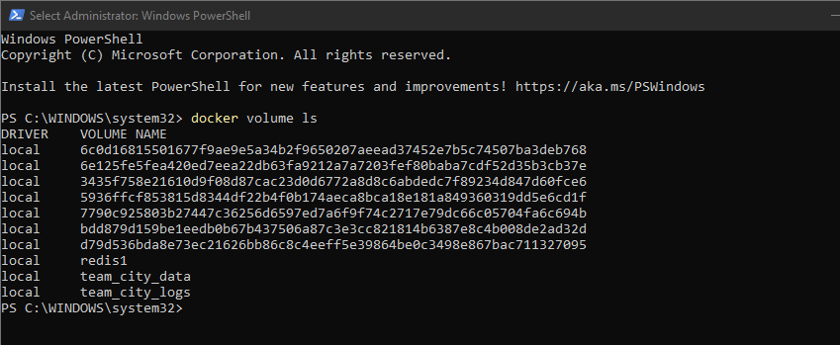

1. **Create a new Volume:-**

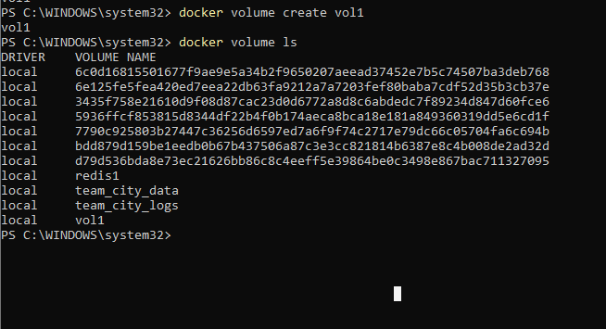

**3.Mount a Volume with a container:-**

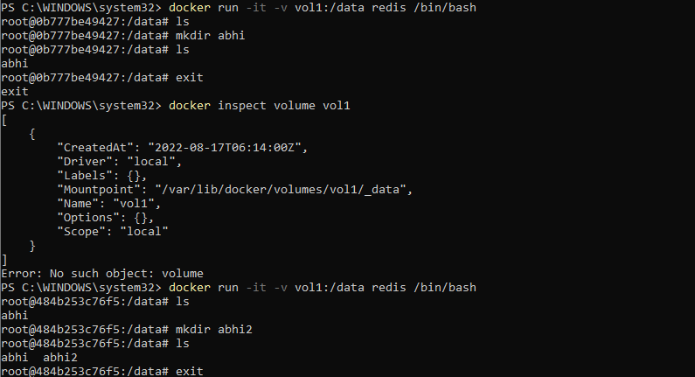

**4.Exited from container and restart again to see the persistent of Docker Volume**

